[IS216] Extra Exercises - Week 2 - CSS Basics

Objectives
● To understand how CSS enables styling of HTML elements
- To apply the use of CSS to HTML web pages.

Instructions
● Questions with no asterisk mark are easy peasy.
● Questions marked with * are slightly challenging.
● Questions marked with ** are challenging.
● Questions marked with *** are very challenging.

Download
● Resources: Click here
- Sample Solutions: Click here

NOTE: If you spot any mistakes/errors in the questions, please contact your instructors by email and state the issues. We will try to address it as soon as possible.

Question 1 – Fruit (*)

Go to fruit directory.

|--fruit
|-- apple.jpg
|-- fruit.html (to do)
|-- fruit-pic.jpg

Complete fruit.html with appropriate CSS styling such that the following will be displayed on a web browser. This web page has a side menu bar that will not scroll with the content on the right.

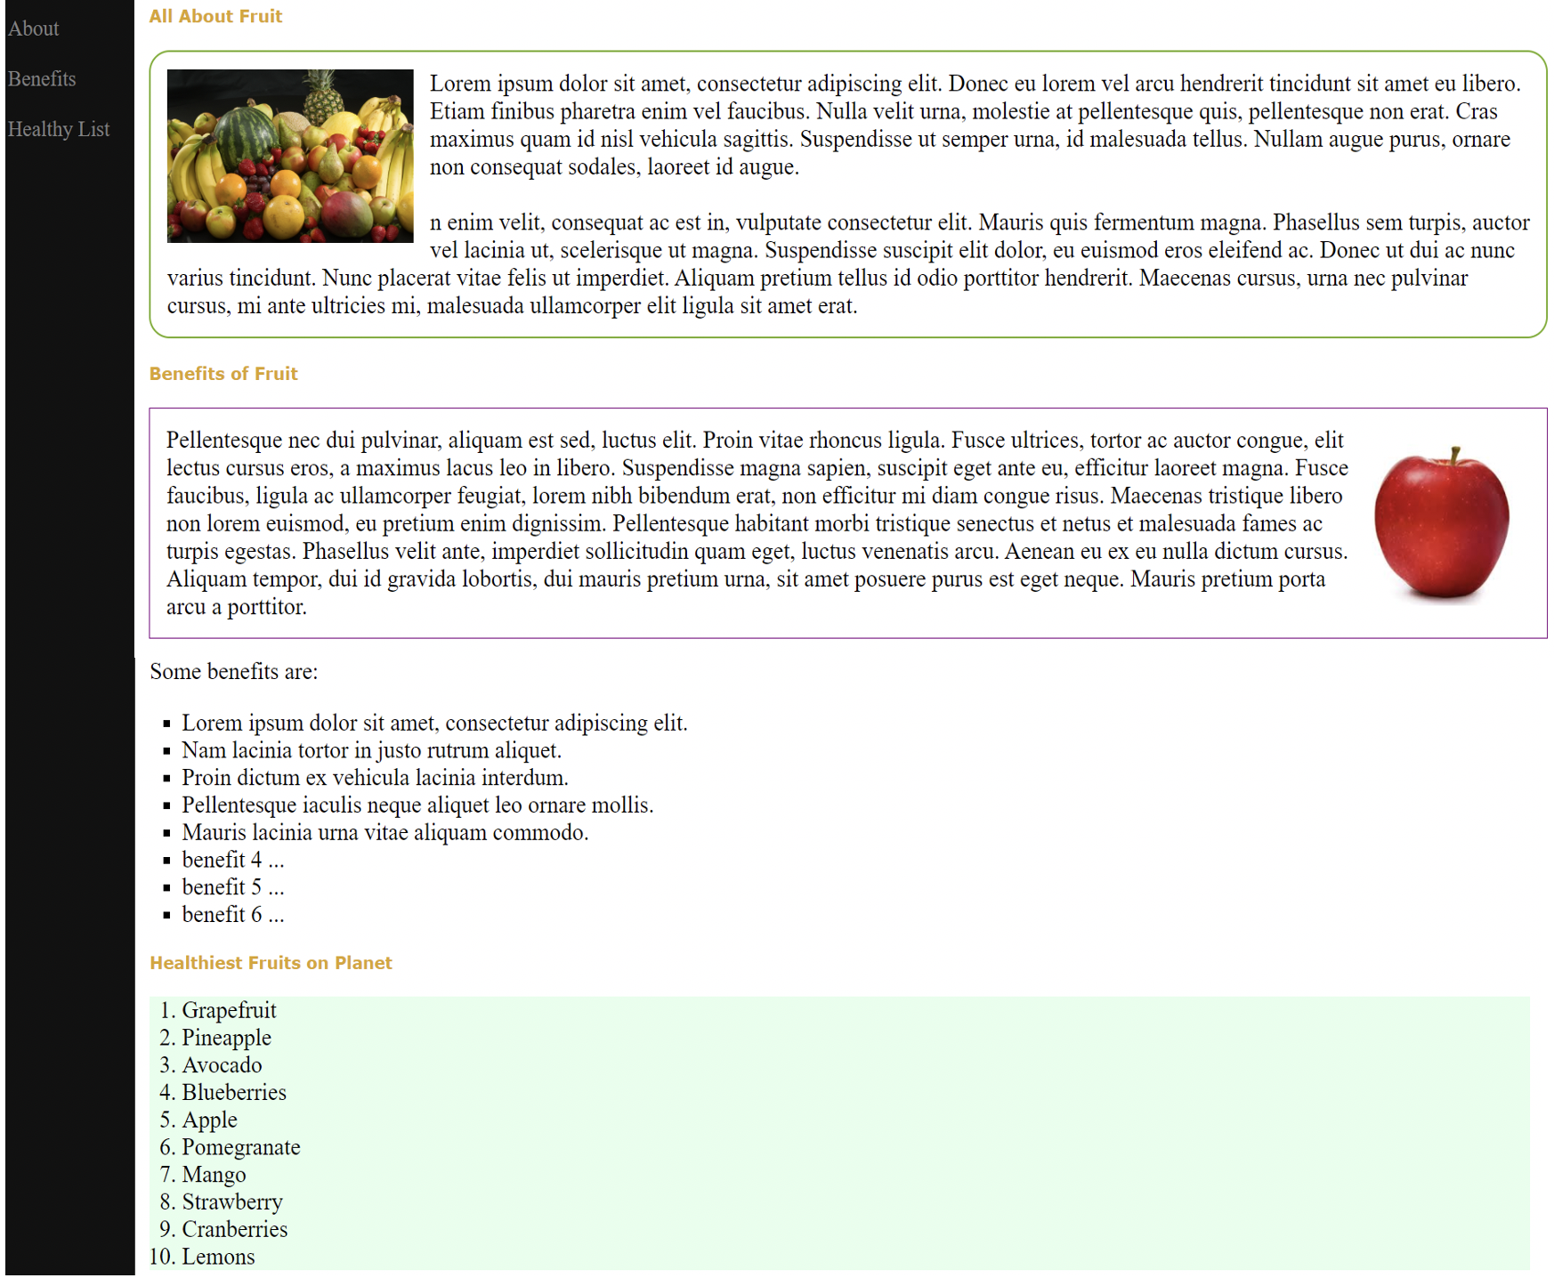
Question 2 – Learn (*)

Go to learn directory.

|-- learn
|
|-- images
|-- {various images}
|
|-- learn.html
|

1. Complete learn.html with appropriate CSS styling such that the following will be displayed on a web browser (in the main box)
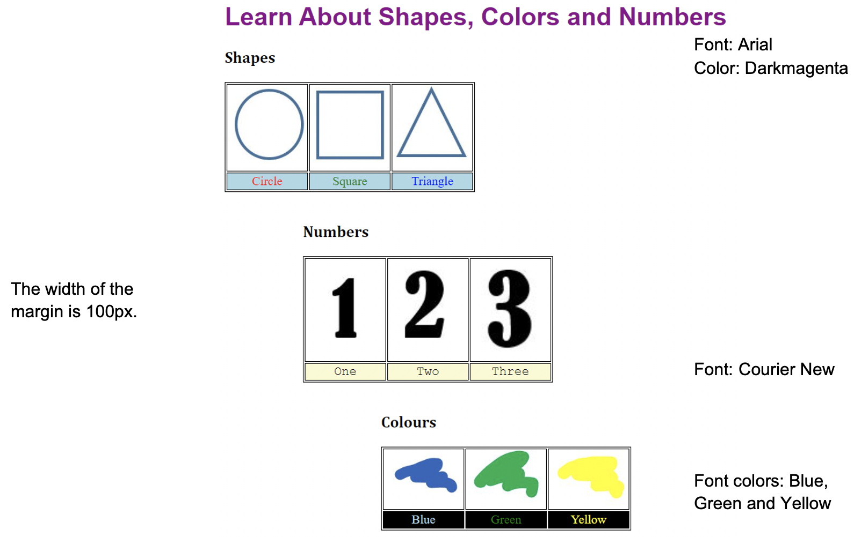

2. The font size of the row in the table will increase to 30px when the user does a mouse over.
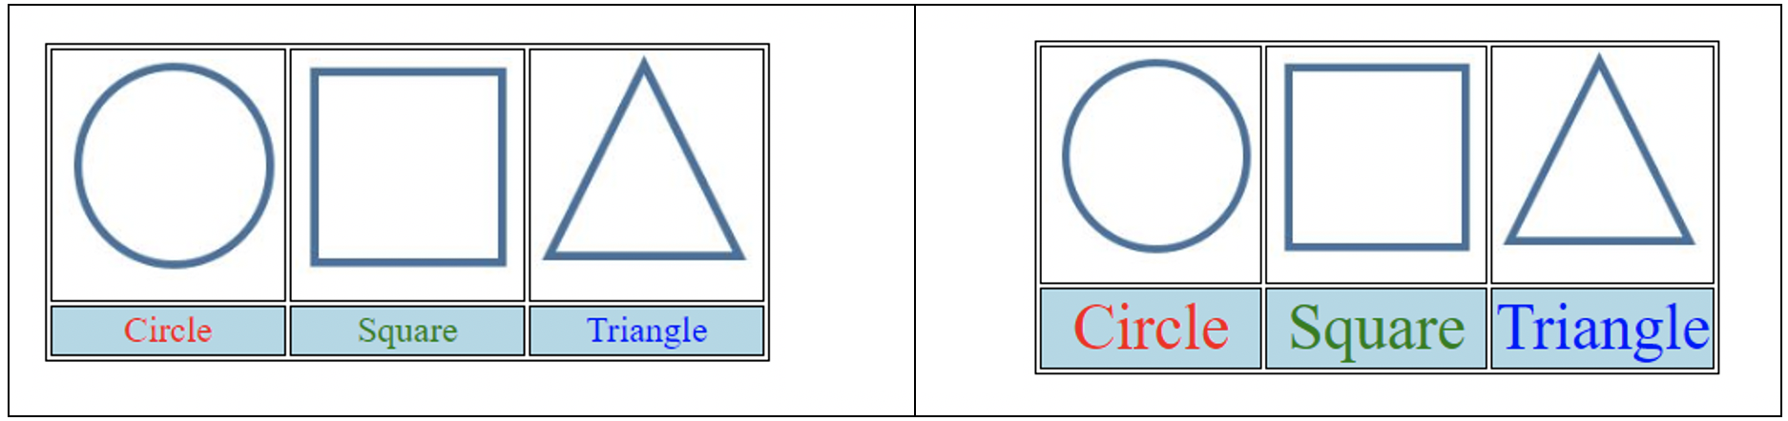
Question 3 – Marketplace (**)

Go to marketplace directory.

|-- marketplace
|
|-- images
|-- coffee.jpg
|-- fruit.jpg
|-- marketplace.jpg
|-- veg.jpg
|
|-- marketplace.html
|

1. Complete marketplace.html with appropriate CSS styling such that the following will be displayed on a web browser.
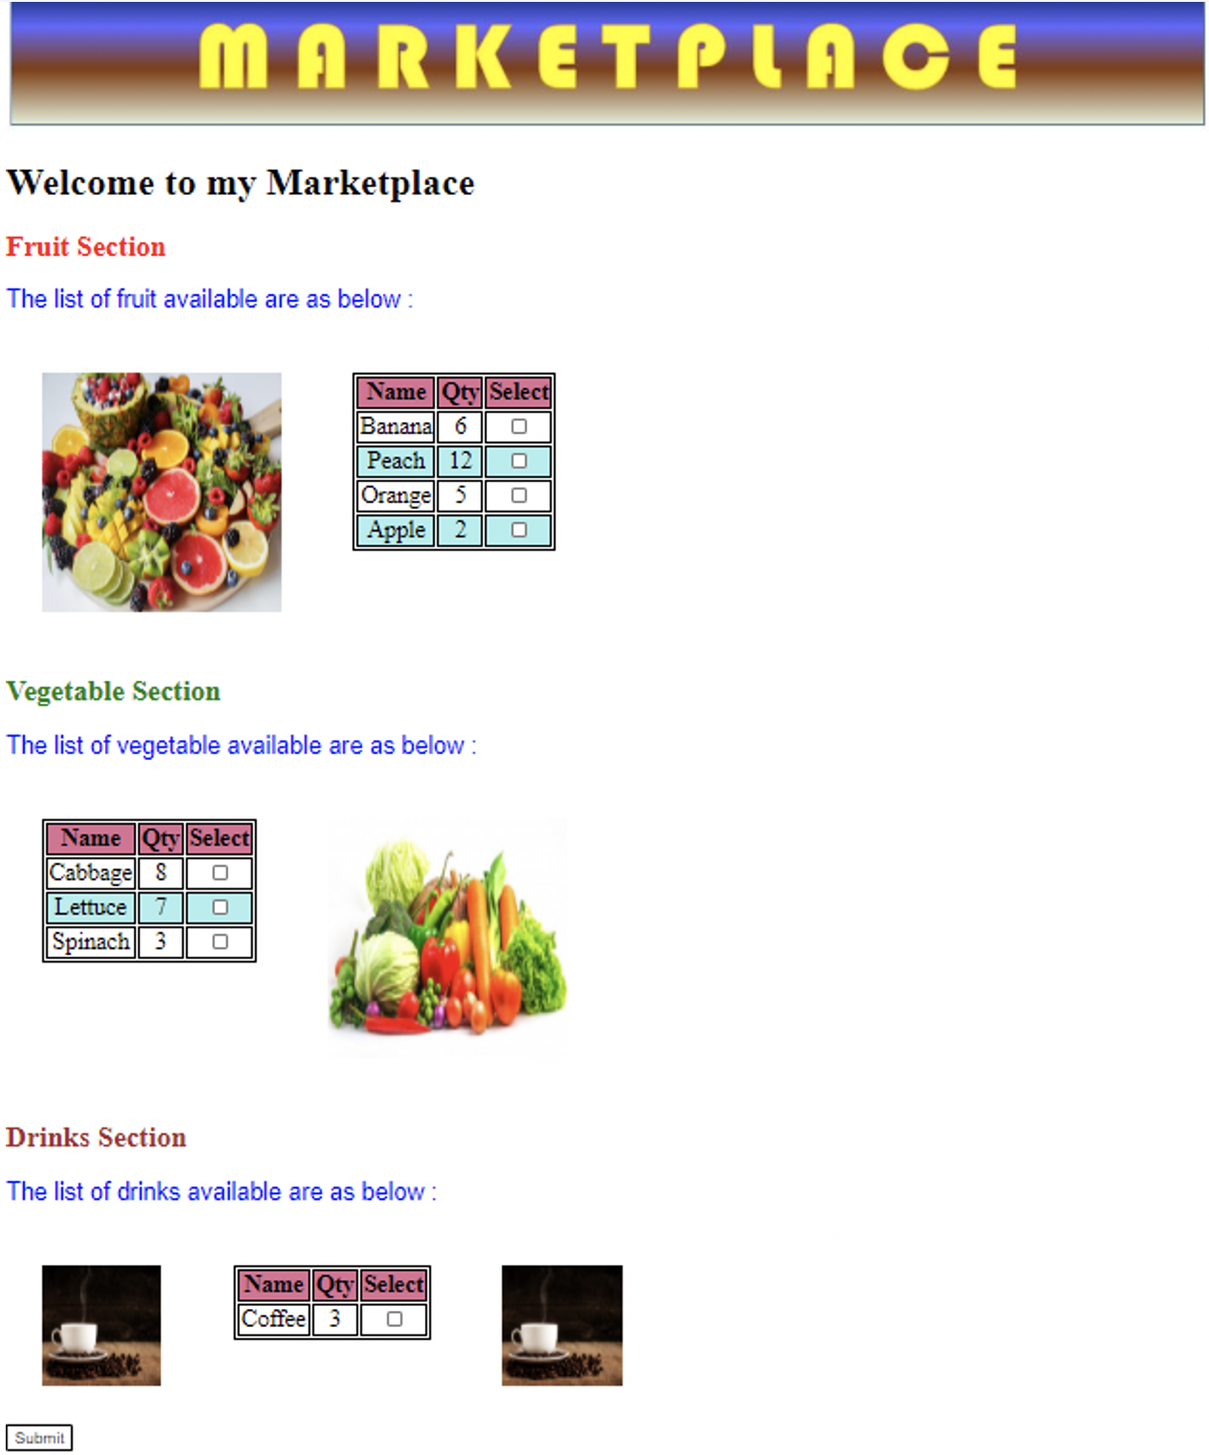
2. To make the web page more interesting, use CSS to display a blue color box with a white tick when the user clicks on each checkbox. An example is shown below.

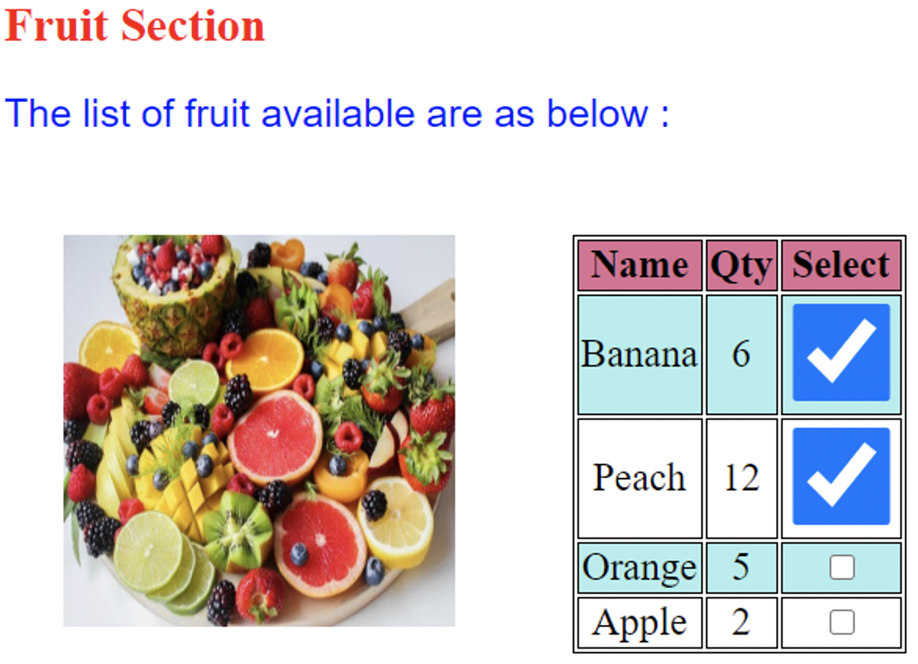

Question 4 – RecipeHub (**)

Go to recipehub directory.

|-- recipehub
|
|-- recipehub.html
|-- recipehub.css

- Complete recipehub.css with appropriate CSS styling such that the following will be displayed on a web browser when recipehub.html is loaded.
- The steps are listed below:
- The header spans the full width at the top of the page.
- The nav links sit in a single row, evenly spaced.
- The recipe (main) content and the sidebar sit side by side, with main roughly twice as wide as the sidebar.
- The four stat blocks in the meta bar sit in one row, spread across the card.
- The two sidebar cards stack vertically with visible space between them.
- The footer spans the full width at the bottom, with the site name on the left and the copyright text on the right.

